# Private Links and Endpoints in AWS

 IN AWS services like Dynamo DB, S3 buckets will not be part of your vpc,

 So for the ec2 instances in your vpc connecting to these services will involve internet  To solve this we have two options

 endpoints:

 Interface endpoints  Gateway endpoints

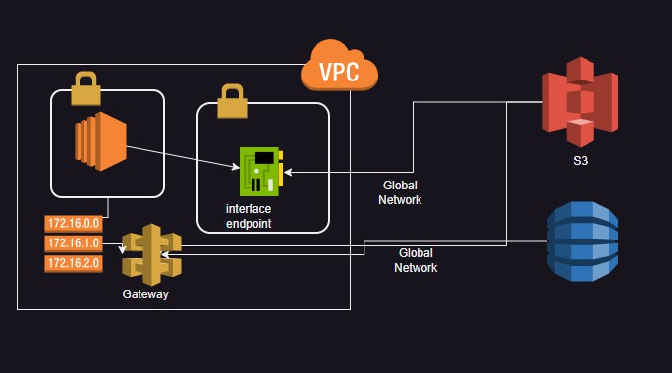

 Private Links

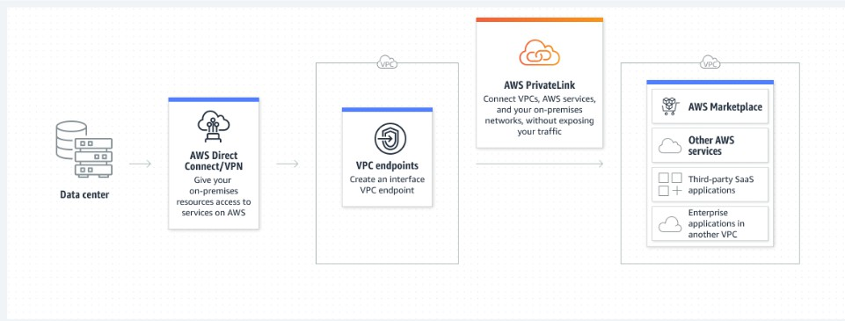

# Private endpoints in Azure

 [Refer Here](https://learn.microsoft.com/en-us/azure/private-link/private-endpoint-overview) for official docs

 creating a private endpoint [Refer Here](https://learn.microsoft.com/en-us/azure/private-link/create-private-endpoint-portal?tabs=dynamic-ip)

 creating a private link service [Refer Here](https://learn.microsoft.com/en-us/azure/private-link/create-private-link-service-portal?tabs=dynamic-ip)

Workshop

